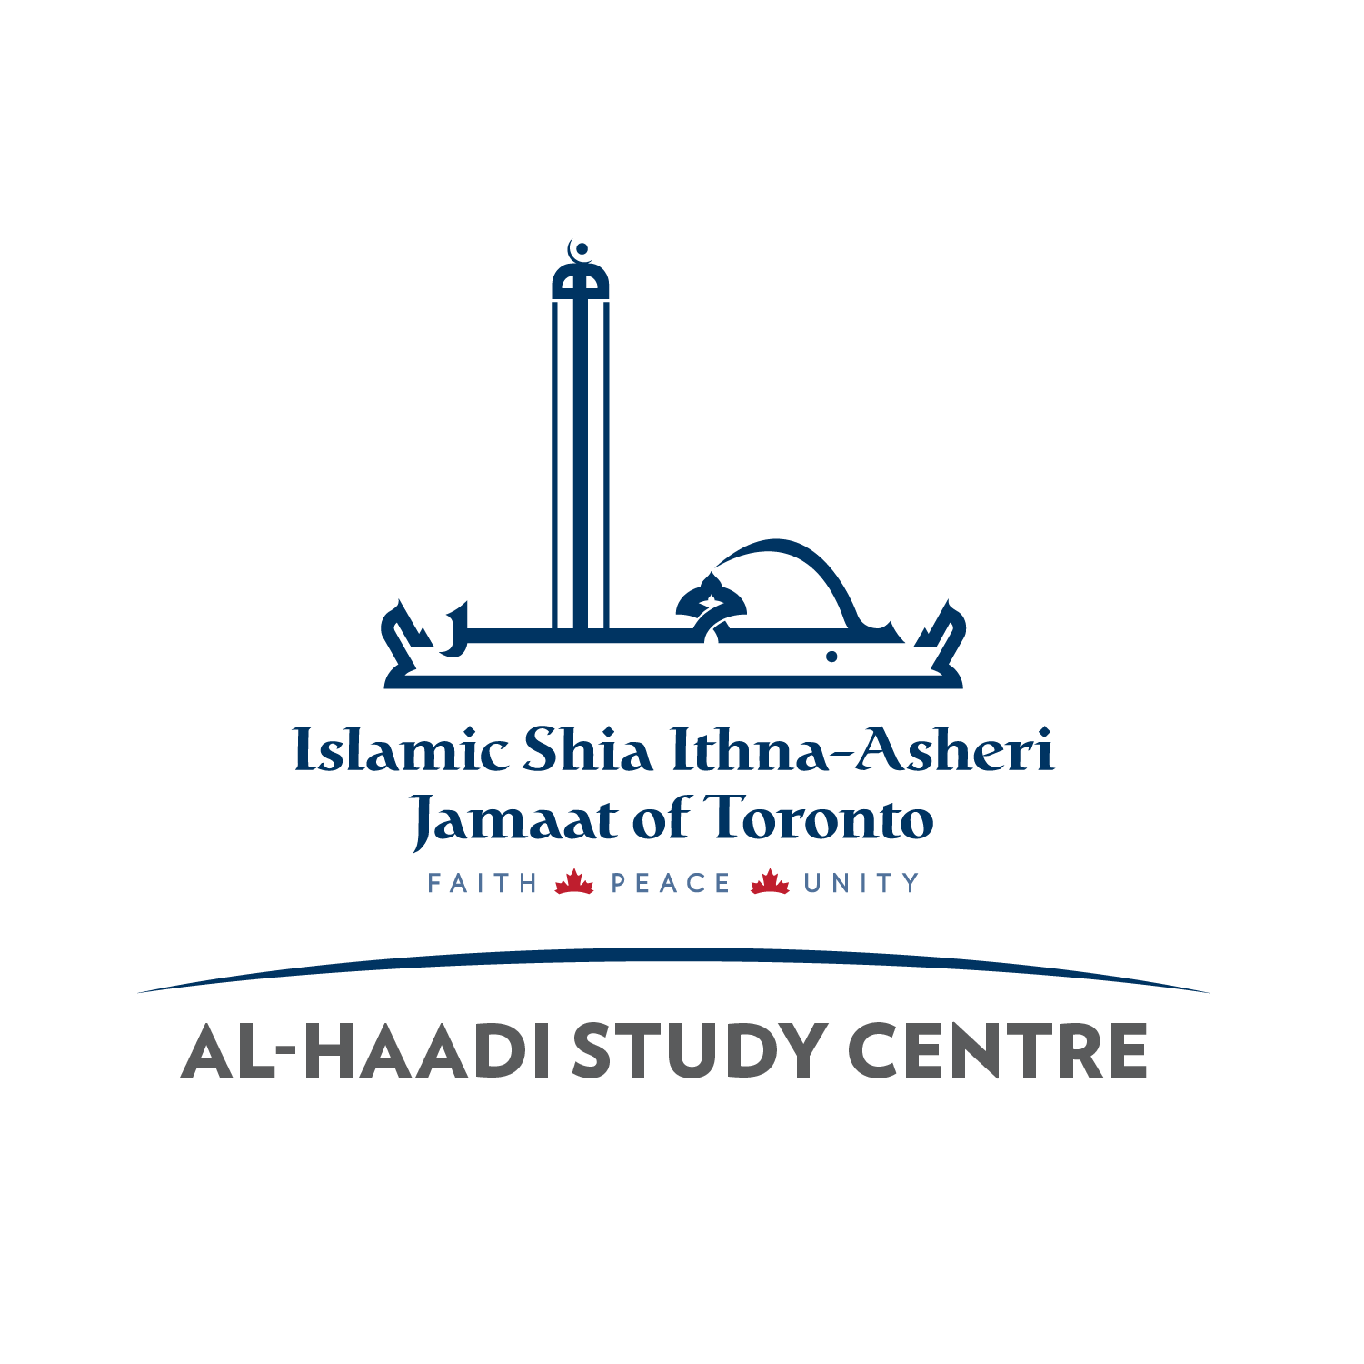
Al-Haadi Request for Economic Exemption (Fee Subsidy) Al-Haadi

Parents who cannot afford the Study Centre fees are requested to fill out the following form and come speak with the Principal & Treasurer. Please note, this form will be kept Strictly Confidential.

Name of Study Centre: _Al-Haadi____________________________________

Father’s/ Legal Guardian’s Full Name: __________________________

Mother’s/ Legal Guardian’s Full Name: _________________________

Number of Children who will attend this Study Centre: _________

Names of Children who will attend this Study Centre:
________________________________________________________

________________________________________________________

Primary Phone #: ________________ Email: __________________

Person requesting exemption (circle): Mother/ Father/ Legal Guardian

Amount of Exemption Requested: ___________________________

Reason for Exemption: ____________________________________

Signature: _______________ Date: _________________

Principal’s Notes: _________________________________________

Principal’s Sign: _____________ Treasurer Sign: ___________

